

**Vietnam Forests and Deltas Program**

A FIELD REPORT

FUELWOOD VALUE CHAIN ASSESSMENT

IN THANH HOA & NGHE AN PROVINCES

**Prepared by Do Hong Anh, Hoang Xuan Ty, Hoang Viet Anh**

**Submission date: 21/10/2014**

*This publication is made possible by the generous support of the American people through the United States Agency for International Development (USAID). The contents are the responsibility of Vietnam Forests and Deltas Program and do not necessarily reflect the views of USAID or the United States Government.*

**CONTENTS**

Executive Summary 1

Selected definitions of terms used in this report 2

1 Introduction 3

2 Method 3

2.1 Clustering design 4

2.2 Field survey 9

3 Data processing and analysis 10

3.1 Data processing for household survey 10

3.2 Data processing for industrial and commercial fuelwood survey 10

4 Findings 11

4.1 Wood supply chain in the region 11

4.2 Sustainable potential wood supply 12

4.2.1 Estimation of fuelwood production by forest type 12

4.2.2 Fuelwood supply estimation for Thanh Hoa and Nghe An 14

4.3 Fuelwood demand 16

4.3.1 Household sector 16

4.3.2 Commercial and Industrial sector 24

4.4 Fuelwood Value Chain Assessment 31

4.5 Key factors driving deforestation and forest degradation 33

5 Recommendations 36

5.1 Review of land conversion in some specific area 36

5.2 Forest land administration improvement in some specific area 36

5.3 Improved stoves 36

5.4 Agriculture residues utilization as an alternative source to fuelwood 36

5.5 Creation of fuelwood source 36

5.6 Further investigation of local industrial fuelwood demand 37

Appendix 38

Abbreviations

|  |  |
| --- | --- |
| FAO | Food and Agriculture Organization of the United Nations |
| FIPI | Forest Inventory and Planning Institute of Vietnam |
| GTZ | German Organization for Technical Cooperation |
| LPG | Liquefied Petroleum Gas |
| MARD | Ministry of Agriculture and Rural Development |
| MDF | Medium Density Fiber board |
| PPMU | Provincial Project Management Unit |
| TCVN 200:1995 | Vietnam Standards 200:1995 |
| VFD | Vietnam Forest and Delta Program |
| VND | Vietnam Dong |

# Executive Summary

This study, funded by Vietnam Forests and Deltas program (VFD), is aiming to assess current situation and future trends of fuelwood consumption and exploitation, the value chain of fuelwood and its relationship with forest degradation and deforestation, and identify key opportunities to design intervention that could lead to more effectively and sustainably use of fuelwood in the project area.

General objectives of the study is to evaluate and assess whole fuel wood value chain in Thanh Hoa and Nghe An provinces, from plantation, exploitation; processing and consumption to identify what are key drivers driving forest degradation and deforestation. In this report, it is understood that deforestation and forest degradation are the concepts used for natural forest, and not used for plantation forest.

During the research, it was found out that wood supply in the area comes from different sources including local natural forest, local plantation forest, home gardens of the residents, and from surrounding area such as from Laos and Ha Tinh province.

Wood is consumed for two major purposes: i) as material for industries including furniture, wood chippers, pulp and paper, MDF, etc., and ii) as fuel for industries which require thermal energy including food/ beverage processing, pulp and paper, MDF, and for households for meal cooking, heating, and additional jobs including pig raising, food/ rice wine making.

There has been a prevailing perception that fuelwood consumed by households is the key factor that driving deforestation and forest degradation in the area. However during the research, it is found out that the fuelwood consumption at households is no longer the major cause of deforestation and forest degradation. Most of fuelwood consumed for households has smaller size in diameter of less than 15cm. The total quantity of fuelwood consumed by households does not exceed the sustainable potential wood supply of the existing forest.

It is suspected that the key direct causes of deforestation and forest degradation in the area include: i) wood demand by local industrial plants including material wood for furniture and MDF; ii) paper material demand for export of Acacia chips that leads to conversion of natural forest to Acacia plantation forest; iii) fuelwood for thermal energy at plants which require wood of larger size (which is a more serious threaten to forest degradation compared to smaller size); and iv) lack of effective enforcement of forest protection regulations that leads to prevailing illegal loggings.

Since material wood is not included in the scope of this research, there is a lack of understanding of wood consumption in this field.

Secondary data on local industries is not sufficient for further analysis as it lacks key information such as source of wood, size of wood.

Specific recommendations include: i) revision of policy on forest conversion; ii) technical assistance to local government staff for forest management; iii) further investigation on wood demand in industrial sector.

# Terms used in this report

**Value Chain**

According to several common definitions, the term “Value chain” denotes a chain of activities and related market, which contributes directly to the production, transformation and distribution to final markets of a single product.

In this report, fuelwood value chain assessment include 3 steps: i) Mapping of the actors; ii) Identifying the activities in the chain; and iii) Identifying money flow to understand the relationships between businesses in the chain and other market players.

**Deforestation**

According to *‘Definitional issues related to reducing emissions from deforestation in developing countries, FAO, 2007’*:

Deforestation implies the long-term or permanent loss of forest cover and implies transformation into another land use. Such a loss can only be caused and maintained by a continued human induced or natural perturbation.

In this report, the concept *‘deforestation’* is only applied to natural forest, and not applied to plantation forest.

**Forest degradation**

According to *‘Definitional issues related to reducing emissions from deforestation in developing countries, FAO, 2007’*:

FAO 2001, 2006: Changes within the forest which negatively affect the structure or function of the stand or site, and thereby lower the capacity to supply products and/or services. Takes different forms particularly in open forest formations deriving mainly from human activities such as overgrazing, overexploitation (for fuelwood or timber), repeated fires, or due to attacks by insects, diseases, plant parasites or other natural sources such as cyclones. In most cases, degradation does not show as a decrease in the area of woody vegetation but rather as a gradual reduction of biomass, changes in species composition and soil degradation. Unsustainable logging practices can contribute to degradation if the extraction of mature trees is not accompanied with their regeneration or if the use of heavy machinery causes soil compaction or loss of productive forest area.

In this report, the concept *‘forest degradation’* is only applied to natural forest, and not applied to plantation forest.

**Sustainable Potential Wood Supply**

According to the report *‘Sustainable Potential Wood Supply’*, FAO, 2008, ‘sustainable potential wood supply’ is the level of supply which can be maintained indefinitely without compromising the ability of the system to supply goods and services for future generations.

# Introduction

Vietnam is a developing country with 70% population living in the rural area, about three fourth of the land is located in the hilly and mountain area with long tradition of fuelwood as a main source of energy. Fuelwood are used in the households for cooking, heating and support to supplement business like rice wine making, food processing.

Sustainable woody biomass from forest is a renewable source of energy that can substitute for fossil fuels in the production of energy and other products, a potentially important tool in the national strategy to reduce greenhouse gas emissions. However as the rural population is continuously increased, the tradition of heavily dependence on fuelwood may increase the pressure on forest and thus lead to forest degradation and deforestation.

Understanding the dimension of fuelwood consumption, the structure and relationship of key stakeholders in the fuelwood supply and demand, and the consequences can help policy maker to design better energy supply system for rural population, mitigate the global warming and to reduce forest degradation and deforestation.

This study, funded by Vietnam Forests and Deltas project (VFD), is aiming to assess current situation and future trends of fuelwood consumption and exploitation, the value chain of fuelwood and its relationship with forest degradation and deforestation, and identify key opportunities to design interventions that could lead to more effectively and sustainably use of fuelwood in the project area.

The study was conducted in 2 provinces Thanh Hoa and Nghe An during September 2014. At industrial level, the consultant team has surveyed several industrial factories that are using wood as fuel in two provinces. At community level, the consultant team conducted interviews with 220 households at 14 communes including 4 districts in Thanh Hoa and 3 districts in Nghe An. Interviews with local officers were also conducted to collect information on social economic condition, current regulation/ policy in forest protection and how it was enforced at local level.

This report present our findings in fuelwood demand side at household level, industrial level, and commercial activity of fuelwood. Finally the value chain of fuelwood and its relationship with forest degradation and deforestation is analyzed and discussed.

# Method

The field study was conducted from 18 to 26 August 2014. Before starting the field survey a desk review was carried out to collect information on the social economic condition as well as the forest resources of the study area. Key secondary data collected at commune level during the desk review are: population density, forest area, data related to climatic condition such as temperature and elevation. It contributed to design the questionnaire and number of samples.

A total of 220 households were selected using stratified random sampling procedure. The process of household selection includes 4 steps: i) selection of cluster; ii) selection of commune from clusters; iii) selection of village from commune; iv) selection of households from village.

The reason to use cluster instead of district to start the selection process is that districts boundary are administrative unit that might not follow nature landscape and social economic condition that drives the behavior of fuelwood consumption. Therefore the design of survey starts firstly with clustering the study area into several stratums (clusters) that are homogenous in term of fuelwood consumption.

## Clustering design

For fuelwood consumption survey, it is recommended to use stratified sampling rather than simple random. This is because we know that the studied population can be physically divided in to homogenous groups with respect to biomass consumption. The stratified sampling, therefore, will lead to greater accuracy in the estimates of fuelwood consumption patterns (smaller estimation errors than simple random sampling with the same sample size).

For this study, following variables are used for stratification.

Table . Variables used for sample stratification

|  |  |  |
| --- | --- | --- |
| **Variable** | **Relation to biomass consumption** | **Data source** |
| Population density 2010 | Basic demographic characteristic, reflect the demand size of biomass consumption. | MONRE 2010 - Commune level population density |
| Mean elevation | Geographic character of a population in relationship with biomass source and consumption. People living in higher altitude usually consume more fuelwood for heating | Global ASTER Digital elevation model, resolution 30 m. Computed as mean value for each commune |
| Mean slope | Reflect the terrain condition and accessibility | Global ASTER Digital elevation model, resolution 30 m. Computed as mean value for each commune |
| Distance to road | Reflect the level of access to transportation | Distance to national road, inter-provincial road, inter-district road. Computed as mean value for each commune |
| Average annual temperature | Area with lower temperature would need more fuelwood for heating and cooking | WorldClim, global climate data at 1 km resolution. Computed as mean value for each commune |
| Min temp of coldest month | Area with lower temperature would need more fuelwood for heating and cooking | WorldClim, global climate data at 1 km resolution. Computed as mean value for each commune |
| Cover % of natural forest area | Reflect the source of fuelwood | MARD, National forest inventory 2010, available at provincial level |
| Cover % of plantation forest area | Reflect the source of fuelwood | MARD, National forest inventory 2010, available at provincial level |

All of the above information is extracted for each commune in Thanh Hoa and Nghe An provinces. To classify all commune in the study area into homogenous group, the K-mean clustering method is employed. This procedure uses non-hierarchical clustering of observations according to MacQueen's algorithm[1]. The result of this process is 6 clusters of commune that are similar in term of biomass consumption (Fig1 and Fig 2). After some initial analysis of the clustering result, it was found that the size of cluster 1 is very small compare to other clusters. Cluster 1 represent communes and wards with very high population density that are mainly located in city and big towns. This area is not the target of this study, therefore it was decided to exclude cluster 1 from the sampling scheme.

Table . Characteristics of cluster

|  |  |  |  |  |  |  |  |
| --- | --- | --- | --- | --- | --- | --- | --- |
| **Cluster** | **Avg. area of natural forest (ha/person)** | **Avg. area of plantation forest (ha/person)** | **Avg. ratio of natural forest by commune (%)** | **Avg. ratio of plantation forest (%)** | **Avg. elevation (m)** | **Avg. annual temperature (C deg)** | **Avg. temperature of the coldest month (C Deg)** |
| 1 | 0.000 | 0.00 | 0.0 | 0.7 | 12.2 | 21.7 | 13.9 |
| 2 | 0.000 | 0.00 | 0.1 | 1.8 | 14.2 | 24.3 | 14.4 |
| 3 | 0.021 | 0.06 | 4.0 | 20.1 | 46.9 | 24.2 | 14.3 |
| 4 | 0.058 | 0.09 | 10.1 | 19.6 | 84.4 | 24.1 | 14.0 |
| 5 | 0.925 | 0.11 | 49.2 | 7.9 | 293.6 | 23.0 | 12.4 |
| 6 | 2.262 | 0.11 | 54.6 | 3.8 | 669.1 | 20.9 | 10.0 |

Looking at key parameters of the cluster (Table ) it can be seen that cluster 1 to 6 is spreading from delta (cluster 1 and 2) to forest and mountain area (cluster 5 and 6) with cluster 3 and 4 representing the high land area in between. The elevation of the cluster reflect this pattern very clearly. The distinct characteristic of cluster 5 and 6 is that the coverage of natural forest is very high, 49.2% and 54.6% respectively. People in these clusters have easy access to natural forest and consequently easy access to high quality fuelwood.

In cluster 3 and 4 the most important character is the high coverage of plantation forest, 20.1% and 19.6% respectively. Cluster 2 and 1 has almost no natural forest and very little plantation forest.

A brief description of each cluster is presented below:

*Table 3. Description of cluster*

|  |  |  |
| --- | --- | --- |
| **Cluster** | **Interpretation** | **Forest to Delta Characteristics** |
| Cluster 6 | Highest mountainous area, highest coverage of natural forest, less coverage of plantation forest, farthest to main truck roads, lowest temperature of the medium coldest month temperature, lowest population density | Forest |
| Cluster 5 | High mountainous area, high coverage of natural forest, more plantation forest, closer to main truck roads, many depressed communes, less cold, higher population density |  |
| Cluster 4 | Low mountain and hills, less natural forest coverage, high plantation forest coverage, close to main truck roads, less depressed communes, less cold, population density increase significantly. |  |
| Cluster 3 | Major hills and flat land, almost no natural forest, most plantation forest coverage, very close major roads, almost no depressed communes, not cold, high population density |  |
| Cluster 2 | Delta land, no natural forest, few plantation forest, closest to major roads, warmest, highest population density | Delta |

Map of these clusters in Thanh Hoa and Nghe An are as below:

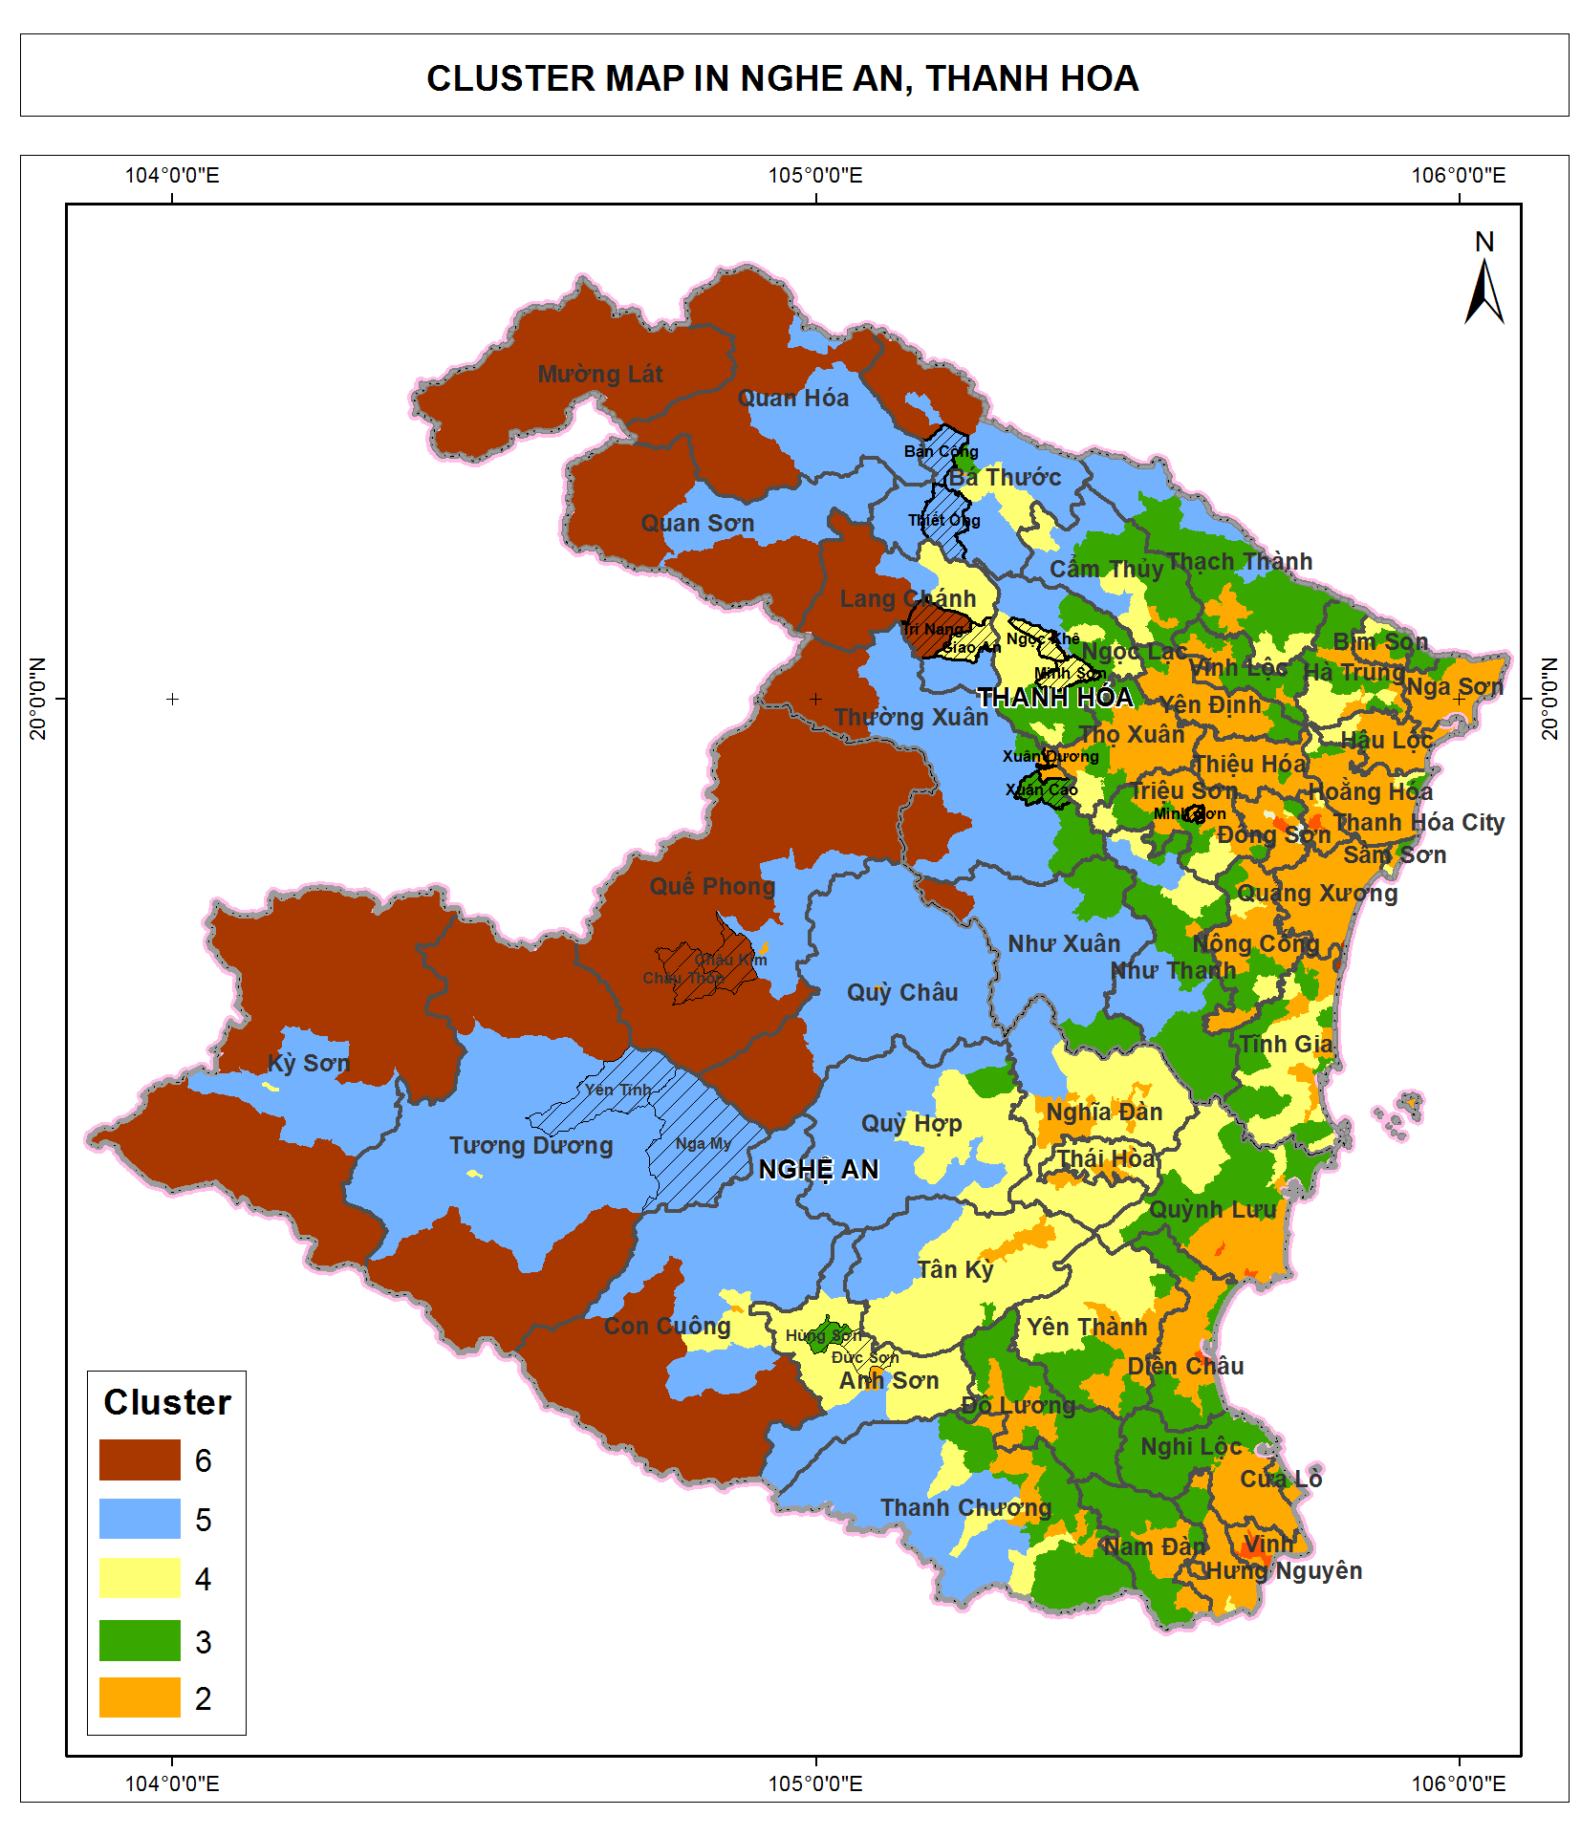

*Figure 1. Map of cluster in Thanh Hoa and Nghe An*

Once the clusters were identified and characterized the communes were selected with advice from provincial VFD officers so that each cluster have at least one communes. The list of commune selected for field survey is presented in Table 4. From each commune, one village is selected with the advice of the commune PPC. From each village, about 15 household is selected with the advice of village’s head so that they represent different type of economic condition: poor household, rich households, household with and without pig raising.

Table 4. List of commune selected for field survey

|  |  |  |  |  |
| --- | --- | --- | --- | --- |
| **STT** | **Province** | **District** | **Commune** | **Cluster** |
| 1 | Thanh Hóa | Bá Thước | Thiết Ống | 5 |
| 2 | Thanh Hóa | Bá Thước | Bản Công | 5 |
| 3 | Thanh Hóa | Lang Chánh | Giao An | 4 |
| 4 | Thanh Hóa | Lang Chánh | Trí Năng | 6 |
| 5 | Thanh Hóa | Ngọc Lặc | Minh Sơn | 4 |
| 6 | Thanh Hóa | Ngọc Lặc | Ngọc Khê | 4 |
| 7 | Thanh Hóa | Thường Xuân | Xuân Dương | 2 |
| 8 | Thanh Hóa | Thường Xuân | Xuân Cao | 3 |
| 9 | Nghệ An | Anh Sơn | Hùng Sơn | 3 |
| 10 | Nghệ An | Anh Sơn | Đức Sơn | 4 |
| 11 | Nghệ An | Tương Dương | Yên Tĩnh | 5 |
| 12 | Nghệ An | Tương Dương | Nga My | 5 |
| 13 | Nghệ An | Quế Phong | Châu Kim | 6 |
| 14 | Nghệ An | Quế Phong | Châu Thôn | 6 |

In this selection of sample, cluster 2 is represented by only 1 commune. Cluster 2 has more population, higher population density. But the size of sample is smaller because VFD PPMU suggested that survey should be conducted in high land area where there are more forest coverage and more project activities.

Table 5. List of commune selected for field survey

|  |  |  |  |
| --- | --- | --- | --- |
| **Geographic area** | **Population (person)** | **Natural forest area (ha)** | **Plantation forest area (ha)** |
| Thanh Hoa and Nghe An | 6,501,383 | 1,037,561 | 216,659 |
| Cluster 6 | 245,812 | 513,817 | 22,734 |
| Cluster 5 | 539,052 | 455,911 | 53,826 |
| Cluster 4 | 824,786 | 43,159 | 58,844 |
| Cluster 3 | 1,357,861 | 24,048 | 73,820 |
| Cluster 2 | 3,241,477 | 625 | 7,344 |
| Cluster 1 | 296,573 | 0 | 90 |

## Field survey

***Household fuelwood consumption***

A questionnaire is designed for household interview. For each commune, one village is introduced by commune officer for household interviews. The criteria for the commune officer to introduce the village is that the village should be of average income compared to the whole commune.

At each village, at least 15 households introduced by the village head participated in the interview. The selection of household is random by the village head. Given an average village have about 100 to 150 households, the sample size of 15 household for one village were considered as sufficient.

Commune officers (including people’s committee’s representative and/or forest rangers) were interviewed to find out the trend of household fuelwood consumption in the past and near future.

In total, 220 households, two restaurants and one primary school were visited for further understanding of residential demand for fuelwood.

***Local industrial consumption***

Seven local industrial plants including three in Thanh Hoa and four in Nghe An were visited for interview and observation for fuelwood demand, including: 3 paper mills, 1 MDF, 1 wood chipper and 2 tea plants. Patterned of fuelwood consumption at industrial plan were collected using a semi-structured interview. Key information and questions to be investigated are:

* What is the major product of the plant
* What is the installed capacity
* What is the actual capacity
* The type of thermal equipment: furnace, boiler.
* Type of fuel: fuelwood, coal, oil
* Quantity of fuel use per day
* Price of fuel: current and historical; comparison with alternative fuel
* Trend of fuel demand, future plan for fuel switch and reason

***Wood middlemen investigation***

The consultant team visited two middlemen, one in Thanh Hoa and one in Nghe An. In-depth interviews were conducted with the middlemen to further understanding commercial demand for fuelwood and actors of fuelwood value chain, and value created by each activity in the chain. Key information to be investigated from the middleman are:

* Location of exploitation
* Quantity of daily exploitation
* Cost: exploitation, loading, legal document, transportation
* Distance of transportation
* Quality and type of wood
* Selling price
* Who are the current and potential buyers

# Data processing and analysis

After collecting all the data, some correction of the data entry errors or logical errors was conducted. During this process the household with very high or very low value compare to their neighbor is selected for reviewing. The survey team revisited the raw questionnaire of those households and discuss the possibility of the value and make necessary adjustment. The questionnaire was designed in such a way that some questions can be used to cross check the another ones, therefore if some key questions can be confirmed as correct they can be used to correct the others. The final database is stored in Excel and is attached to the final report.

## Data processing for household survey

220 households were surveyed to identify household fuelwood demand. The major uses of fuelwood are for following purposes:

* Meal cooking
* Animal cooking
* Additional jobs: distilling alcohol, making tofu, making rice leaf

It is assumed that for the same model of fuel consumption of each cluster, the amount of fuelwood used for meal cooking for one person is homogenous. Therefore fuelwood consumption estimated for one person could be used to calculate the consumption of clusters.

Similarly, fuelwood consumption is estimated for one pig life cycle for each cluster.

It is not possible to estimate fuelwood consumed for additional jobs because it would will require details investigation of fuelwood consumed for one unit of alcohol, tofu, rice leaf, etc. Given the time frame of the research, these details cannot accurately collected.

## Data processing for industrial and commercial fuelwood survey

Investigation on commercial fuelwood is only conducted at one selected site of each province. A larger scale of investigation is not considered because this involve certain risks for the investigator while working with the middlemen who purchase illegal fuelwood. Therefore quantitative data analysis is only conducted in a very small scale to identify the commercial fuelwood amount of specific geographic area of investigation in each province. The data for commercial fuelwood consumption and residential fuelwood consumption will be compared to identify the key factors that create the pressures on exploitation of natural forest trees, especially the larger trees.

Even though material wood is not of the subject of this research, investigation have been done with middlemen who purchase material wood including acacia traders for wood chippers for paper material, and bamboo traders who then sell bamboo to construction works to be used a pillars. This is to understand the price of material wood compared to fuelwood and the pressure on the natural forest which are being converted into plantation forest for material wood for higher value.

Investigation at local industrial plants were conducted at the plants which use fuelwood for their thermal equipment, and those which use coal and dust coal as an alternative fuel. The data will be qualitatively analyzed to further understand who would use fuelwood, why they would use fuelwood instead of other fuel, and what would be the future trend on the fuelwood consumption at these local industrial plants.

In order to quantitatively estimate local industrial demand for fuelwood, data for total capacity by each industrial sector by district is needed. Each industrial sector such as paper mill, tea processing, MDF manufacturing, alcohol and beverage, food processing has a typical production procedure and a typical indicator for fuel consumption per product unit which can be used as a reference. Therefore data for total capacity by industrial sector is needed to estimate the total fuel demand.

Since there is not data on local industrial plants available with specific information on production capacity, a quantitative estimation of fuelwood demand for the local plants cannot be done with reliability.

# Findings

## Wood supply chain in the region

Fuel Wood

Households

Home Garden

Production Plants using thermal energy

- Pulp and Paper

- MDF

- Food processing (tea, etc.)

- Furniture, etc.

Natural Forest

Processing Plants:

- Wood chipper

- Saw mills

Export

- Wood chips

- Sawn timber

Plantation Forest

Material Wood

Other production plants (not using thermal energy)

- Furniture

Surround-ing area

*Figure 2. Wood supply chain in Thanh Hoa and Nghe An*

Agninergy

The above chart describes the wood supply chain in Thanh Hoa and Nghe An provinces. The wood comes from three major local sources: i) plantation forest; ii) natural forest; and iii) home garden. Beside these local sources, wood supply to Thanh Hoa and Nghe An also comes from surrounding areas such and Ha Tinh, Quang Binh provinces and nearby provinces of Laos PDR.

Wood is used for two major purposes, as fuel, and as material. Another purpose of wood use is to make houses for local people, especially ethnic people who have long traditions of building wooden houses.

Supply of *material wood* comes from natural and plantation forest, and partly from home garden. Major species of plantation forest in Thanh Hoa and Nghe An are Acacia and Bamboo. All Acacia is to supply to wood chippers located in Thanh Hoa and Nghe An. There is not an Acacia pulp plant in the area. The chips are then exported mainly to Japan, Taiwan, and China.

Part of Bamboo harvest is supplied to several Bamboo pulp and paper plants in the area. The rest is supplied as construction materials to the clients within the area and other provinces from the North to the Central of Vietnam.

Material wood from natural forest is supplied to sawmills to produce sawn timbers which are then supplied to furniture manufacturers for export. The wood from natural forest which cannot be used for furniture manufacturing (because of the quality or curved shape) will be supplied to MDF plants as material.

A small amount of wood from home garden of households such as *Melia azedarach* and *Chukrasia* *tabularis* are supplied for furniture material.

Supply of *fuelwood* comes from natural forest, plantation forest, and home garden. Fuelwood consumed at households comes from all these three sources while most fuelwood consumed at industrial plants such as MDF, pulp and paper, and food processing plants (including tea plants). The fuelwood from natural forest are the wood which cannot be used for furniture manufacturing because of the quality or curved shape.

The chart describe the general picture of wood supply in the region. This research is to focus on fuelwood consumption at households and industrial plants.

## Sustainable potential wood supply

### Estimation of fuelwood production by forest type

From forest management view point, there could be an optimal amount of fuelwood removed from forest, in term of dead wood and litter fall, without too much effect on the ecological condition of the forest. Some silviculture measure, for example forest enrichment, often include the practice of removing some bushes, lianas and pioneer trees to give space for more valuable species or to plant new valuable species. This type of activities could yield certain amount of fuelwood to be collected sustainably.

To estimate the fuelwood production of Thanh Hoa and Nghe An a literature reviewed was conducted and the value of forest with similar condition is transferred to be used in fuelwood supply estimation. The review is based on two set of information: i) the natural production of litter fall which could partly be collected and use without much damage on the forest; ii) fuelwood production from other countries with forest condition similar to Vietnam. When the range of value from literature is wide, the principle is to be conservative and use the lower range of the value.

Table 6. Litter fall production of different forest type

|  |  |  |  |  |
| --- | --- | --- | --- | --- |
| **Forest type** | **Country** | **Litter fall production (tons/ha/year)** | **Branch proportion %** | **Source** |
| Broad leaf forest | New Zealand | 6.1 |  | M.J. Daniel 1975[2] |
| Tropical broad leaf forest | Southern Brazil | 6.8 |  | S.M. Bergamini, et al 2009[3] |
| Broad leaf forest | Fujian, China | 11 | 11-26 | Y.S. Yang et all 2003[4] |
| Broad leaf forest | Vinh Phuc, Vietnam | 5.9-8.1 | 20-43 | D.T. Le 2009[5] |
| Pine forest | North East Vietnam | 6.2 | 43 | T.T. Dang 2009 |

Litter production and the proportion of branch from several studies is presented table 6. The litter production is in the range of 5.9-11 tons/ha/year and the branch proportion is between 11% to 43%. The lower range of studies in Vietnam is selected to use that give:

Annual branch (in litter fall) production = 5.9 tons/ha x 20% = 1.18 tons/ha

Assume that 20% of the branch production could potentially be collected and used as fuelwood, it give:

Annual collectable branch production = 1.18*20% = 0.236 tons/ha/yeas.

In addition to litter fall, fuelwood can also be extracted from forest by mean of residue, small round wood (SRW) and thinning. Several study about fuelwood production of forest in Finland, India and UK is presented in Table.

Table 7. Fuelwood production from 4 different forest type

|  |  |  |
| --- | --- | --- |
| **Fuelwood production** | **Forest type and location** | **Source** |
| 26 m3/ha/year | Conifer forest, Finland | Silva Fennica 44(2) research articles. The Finnish Society of Forest Science · The Finnish Forest Research Institute |
| 2.2 m3/ha/year | Deciduous forest, India | Food & Agriculture Org., Jan 1, 1989 - Arid regions forestry |
| 23 m3/ha (total fuelwood at time of measurement) | Homestead forest, South India | Agroforestry Systems, March 1994, Volume 25, Issue 3, pp 243-262 |
| 2.9 m3/ha/year | Temperate forest, UK | UK BIOMASS Energy Centre |

Since there is no study conducted for Vietnam, the value of fuelwood production of 2.2m3/ha/year for forest in India is selected to be transferred to use in this study. To be more conservative it have been decided to reduce this value by 20% that make the fuelwood production of 1.76tons/ha/year.

Together with the collectable branches mentioned earlier, the total collectable fuelwood production used for this study is: 1.76 + 0.236 = 1.996 tons/ha/year. In order to make a more realistic estimation, the fuelwood production is adjusted by forest type and forest standing stock. It is anticipated that a forest with higher standing stock would be able to produce more fuelwood but the relationship is not linear. Therefore the standing volume is used as a reference but the adjusted weight is assigned by expert knowledge. For plantation forest fuelwood is estimated as 10% of the mean annual increment with the assumption of 8 year rotation.

Table 8. Adjusted fuelwood production of different forest type. Average standing volume is based on FIPI data[6]

|  |  |  |  |  |
| --- | --- | --- | --- | --- |
| **Forest** | **Standing volume (m3/ha)** | **Fuelwood production (tons/ha/year)** | **Adjusted weight** | **Adjusted fuelwood production (tons/ha/year)** |
| **Broad leaf rich** | 280 | 1.996 | 1.00 | 1.996 |
| **Broad leaf medium** | 163 | 1.996 | 0.80 | 1.597 |
| **Broad leaf poor** | 80 | 1.996 | 0.70 | 1.397 |
| **Broad leaf regrowth** | 50 | 1.996 | 0.50 | 0.998 |
| **Mixed woody bamboo** | 98 | 1.996 | 0.60 | 1.198 |
| **Bamboo** | 21 | 1.1 m3/year | | 1.1 |
| **Rock mountain forest** | 80 | 1.996 | 0.20 | 0.399 |
| **Plantation** | 90 | 10% of MAI – 8 year rotation | | 1.125 |

The total fuelwood supply of Nghe An and Thanh Hoa is estimated using parameter from Table 8 and forest area extracted from forest map of Thanh Hoa and Nghe An 2010. The result is presented in table 9.

### Fuelwood supply estimation for Thanh Hoa and Nghe An

The total fuelwood supply of two province is 1,905,039 tons/ha/year, of which Nghe An supply 1,193,421 tons/year and Thanh Hoa supply 711,617 tons/year. In Nghe An the forest type that provide the most fuelwood are: broad leaf re-growth forest (23.6%), broad leaf poor forest (22.8%) and broad leaf medium forest (15%); together these 3 type of forest accounted for 61.4% of the fuelwood supply of Nghe An. In Thanh Hoa the supply pattern is a bit different with the most important source of fuelwood supply being plantation forest (26.3%), broad leaf regrowth forest (17.3%) and bamboo (14.5%). This is necessary to note that this estimation should be considered as the potential availability of the fuel biomass, this do not include factors that influence the consumption and exploitation behaviour. For example the distance and accessibility to the source would have significant effect on fuelwood exploitation. The type of fuelwood also play important role in consumption’s choice, as mentioned earlier in the fuelwood demand (Section 3.1), where it is prevailing that people prefer natural fuelwood over plantation fuelwood. Thus in Thanh Hoa where plantation forest, mainly Acacia, provide as much as 26% of the total potential fuelwood, the actual consumption from this source could be much smaller. Also the fuelwood consumption at residential is collected local level, because it is not economically profitable to transport small size fuelwood from one place to other. Therefore the abundant of fuelwood at provincial level do not guaranty the sufficient at local level.

Table 9. Annual fuelwood supply in Thanh Hoa and Nghe An by forest type (Unit: tons/year)

|  |  |  |  |  |
| --- | --- | --- | --- | --- |
| **Forest type** | **Nghe An supply (tons)** | **Thanh Hoa supply (tons)** | **Nghe An supply %** | **Thanh Hoa supply %** |
| Broad leaf rich | 118,863 | 20,082 | 10.0 | 2.8 |
| Broad leaf medium | 178,483 | 64,256 | 15.0 | 9.0 |
| Broad leaf poor | 271,898 | 98,574 | 22.8 | 13.9 |
| Broad leaf re-growth | 281,819 | 123,161 | 23.6 | 17.3 |
| Mixed woody bamboo | 63,487 | 83,325 | 5.3 | 11.7 |
| Rock mountain forest | 430 | 31,467 | 0.0 | 4.4 |
| Bamboo | 100,081 | 103,488 | 8.4 | 14.5 |
| Plantation | 178,360 | 187,263 | 14.9 | 26.3 |
| **Total** | **1,193,421** | **711,617** | **100.0** | **100.0** |

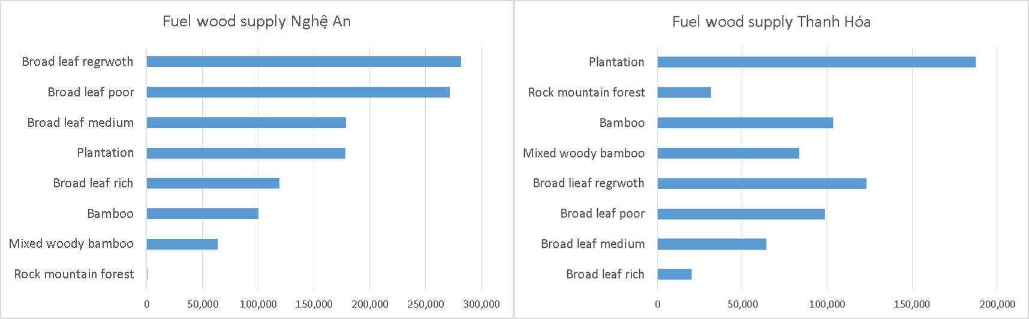

Figure 3. Fuelwood supply by forest type in Nghe An and Thanh Hoa

Looking at the geographic distribution of the supply source Figure there is a clear trend that increase from delta to forest with cluster 6 and 5 dominant in fuelwood supply, cluster 4 and 5 is somewhat sufficient while cluster 2 and 1 provide almost no fuelwood. This trend is clearly reflect the pattern of fuelwood consumption, as presented in section 3.1, that cluster 6 and 5 rely heavily on fuelwood, while cluster 3 and 4 have to use additional source such as agriculture residue, electricity and gas, while cluster 1 and 2 is almost rely on alternative fuel. Detail data on fuelwood supply by district is attached in the Appendix 3.

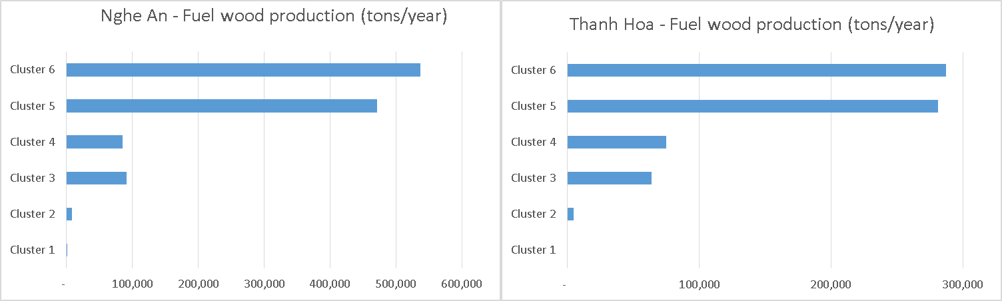

Figure 4. Fuelwood supply by cluster

## Fuelwood demand

### Household sector

#### Current situation and future trend of fuelwood for households

***Quantity of fuelwood consumed per person***

The fuelwood consumption is differentiated amongst the clusters. There is a clear trend that the people living at the high land are more dependent on fuelwood, while people at the low land tend to use less fuelwood and utilize other biomass sources such as agriculture and forest residues. The below table shows the estimation of fuelwood consumed per person by cluster.

*Table 10. Average fuelwood consumption per person by cluster*

|  |  |  |
| --- | --- | --- |
| Cluster | Average fuelwood consumption per month  (kg/ person/ month) | Average fuelwood consumption per year (kg/ person/ year) |
| Cluster 6 | 41.0 | 492.0 |
| Cluster 5 | 42.3 | 507.6 |
| Cluster 4 | 39.5 | 474.0 |
| Cluster 3 | 21.2 | 254.4 |
| Cluster 2 | 8.3 | 99.6 |

Estimation of the total fuelwood consumed by households in Thanh Hoa and Nghe An is as below:

*Table 11. Total fuelwood demand by residential sector of Thanh Hoa and Nghe An*

|  |  |  |  |
| --- | --- | --- | --- |
| Geographic area | Population (person) | Fuelwood consumption per person per year (kg/ person/ year) | Total fuelwood consumption per year (ton/ year) |
| Cluster 6 | 245,812 | 492.0 | 120,940 |
| Cluster 5 | 539,052 | 507.6 | 273,623 |
| Cluster 4 | 824,786 | 474.0 | 390,949 |
| Cluster 3 | 1,353,683 | 254.4 | 344,377 |
| Cluster 2 | 3,241,477 | 99.6 | 322,851 |
| Cluster 1 | 296,573 | - | - |
| **Total population Thanh Hoa and Nghe An: 6,501,383 (persons)** | | |  |
| **Estimation of total fuelwood consumption in Thanh Hoa and Nghe An** | | | **1,452,739 (tons)** |

Estimation of total fuelwood consumption in Thanh Hoa and Nghe An is 1,452,739 ton per annum. On average, fuelwood consumption by local people is 223.5 kg per person per annum.

***Future trends of fuelwood for household cooking use***

There is a trend in urban area where it is more accessible to LPG distribution, people tend to use more LPG and less fuelwood. The below table show details of fuelwood, electricity and LPG consumed per person per, year by surveyed communes.

*Table 12. Average consumption of fuelwood/ electricity/ LPG*

|  |  |  |  |  |  |  |  |
| --- | --- | --- | --- | --- | --- | --- | --- |
| **No** | **Province** | **District** | **Commune** | **Cluster** | **Fuelwood per person per month (kg/person/ month)** | **Electricity cost per person per month (VND/person/ month)** | **LPG cost per person per month (VND/person/ month** |
| 1 | Thanh Hóa | Bá Thước | Thiết Ống | 5 | 22.5 | 8,750 | 39,176 |
| 2 | Thanh Hóa | Bá Thước | Bản Công | 5 | 47.0 | 4,173 | 3,974 |
| 3 | Thanh Hóa | Lang Chánh | Giao An | 4 | 41.9 | 4,283 | 4,167 |
| 4 | Thanh Hóa | Lang Chánh | Trí Năng | 6 | 46.9 | 6,021 | 1,500 |
| 5 | Thanh Hóa | Ngọc Lặc | Minh Sơn | 4 | 42.2 | 4,841 | 5,097 |
| 6 | Thanh Hóa | Ngọc Lặc | Ngọc Khê | 4 | 20.0 | 6,000 | 26,000 |
| 7 | Thanh Hóa | Thường Xuân | Xuân Dương | 2 | 8.3 | 8,257 | 9,436 |
| 8 | Thanh Hóa | Thường Xuân | Xuân Cao | 3 | 19.2 | 3,125 | 27,500 |
| 9 | Nghệ An | Anh Sơn | Hùng Sơn | 3 | 22.3 | 14,271 | 27,708 |
| 10 | Nghệ An | Anh Sơn | Đức Sơn | 4 | 30.0 | 7,222 | 9,583 |
| 11 | Nghệ An | Tương Dương | Yên Tĩnh | 5 | 47.5 | 2,950 | 9,300 |
| 12 | Nghệ An | Tương Dương | Nga My | 5 | 50.7 | 1,833 | 0 |
| 13 | Nghệ An | Quế Phong | Châu Kim | 6 | 35.2 | 313 | 10,313 |
| 14 | Nghệ An | Quế Phong | Châu Thôn* | 6 | - | - | - |

*\* The estimation for commune Chau Thon is not available because all 15 households surveyed in Chau Thon raise pigs. Therefore it is filtered from calculation for fuelwood per person for cooking purpose only.*

For example, Thiet Ong commune in cluster 5, where people use LPG 3 time higher than average, the fuel wood consumption 32% lower than average. Similarity, Ngoc Khe commune in cluster 4 where LPG use is 2 time higher than average, the fuel wood is 40% lower than average.

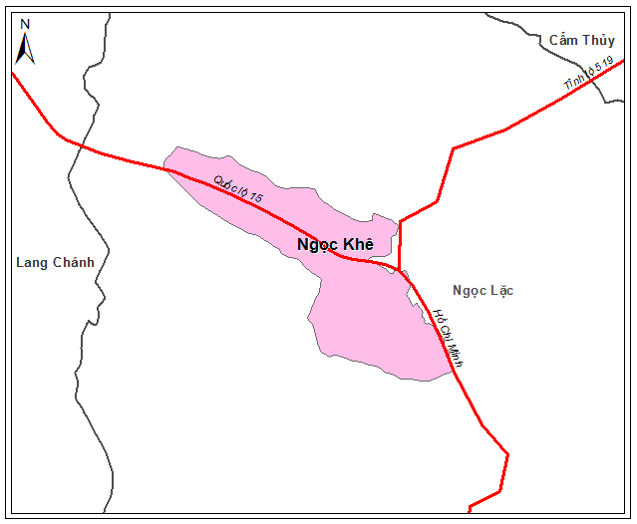 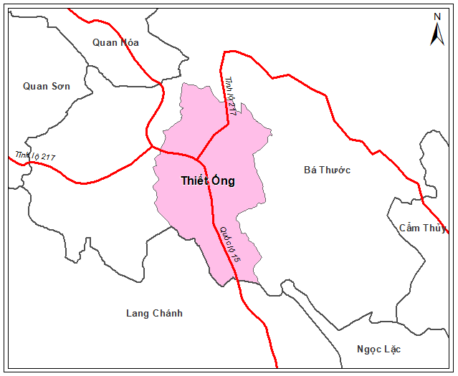

*Figure 5. Maps of Thiet Ong commune and Ngoc Khe with transportation roads*

Geographic location of Thiet Ong and Ngoc Khe commune of cluster 4 are both at intersections of key roads. These two communes are more exposed to urbanization and have easier access to LPG distribution. These are amongst the key factors that impact on residents’ options of energy type. For these two communes, it is clear that people are switching to LPG as an alternative of fuelwood.

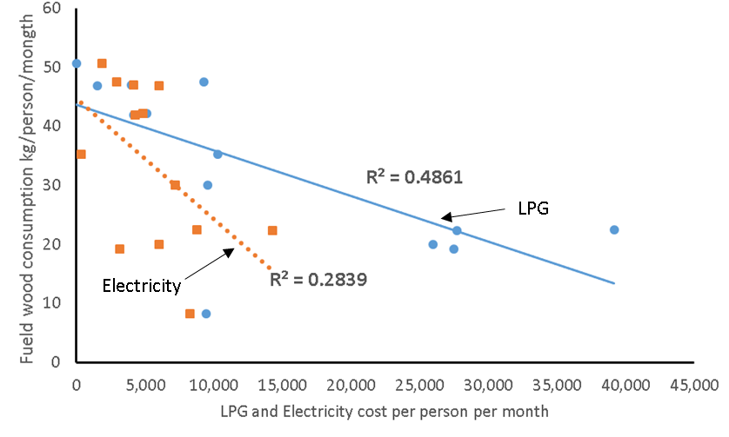

*Figure 6. Scatter plot of fuel wood, LPG and Electricity consumption*

Fig 5 shows the scatter plot of fuel wood versus LPG, and electricity consumption at all surveyed communes. Although the R-square of the correlation is low it still show a clear negative trend where fuel wood demand decrees rapidly with the use of LPG. The relationship between the use of electricity and fuel wood is less clear compare to LPG. This is because electricity is commonly available for all communes through the distribution network while LPG is dependent on transportation, therefore electricity is used more widely throughout the study area. Still a negative trend can be observed with communes in lower land use more electricity and less fuel wood.

In the future when urbanization take place in the area, this trend will continue and the demand for fuelwood will reduce while for LPG will increase.

***Source of fuelwood***

The fuelwood consumption at households by source is estimated as below.

|  |
| --- |
| Total fuelwood consumption for Thanh Hoa and Nghe An is 1,453,740 ton per year, in which it is estimated that:   * From natural forest: 879,773 ton per year, equivalent to 61% * From plantation forest: 329,637 ton per year, equivalent to 23 % * From home garden: 243,294 ton per year, equivalent to 16% |

These numbers are differentiated between clusters as cluster 5 and 6 have more natural forest and cluster 2, 3 and 4 have more plantation forest. The details number is as below:

*Table 13. Source of fuelwood by cluster*

|  |  |  |  |  |
| --- | --- | --- | --- | --- |
| Cluster | % of fuelwood from natural forest | % of fuelwood from plantation forest | % of fuelwood from home garden | % of fuelwood from other source |
| Cluster 6 | 83 | 10 | 6 | 0 |
| Cluster 5 | 84 | 9 | 4 | 2 |
| Cluster 4 | 60 | 30 | 11 | 0 |
| Cluster 3 | 6 | 51 | 6 | 37 |
| Cluster 2 | 0 | 0 | 50 | 50 |

***Types of fuelwood***

The fuelwood consumption at households by source is estimated as below.

|  |
| --- |
| Total fuelwood consumption for Thanh Hoa and Nghe An is 1,453,740 ton per year, in which it is estimated that:   * % of fuelwood of size> 15cm in diameter: 4% * % of fuelwood of size 5-15cm in diameter: 26 % * % of fuelwood of branches<5 in diameter: 70% |

In details, types of fuelwood consumed at households by cluster is as below.

*Table 14. Categories of fuelwood by size by cluster*

|  |  |  |  |
| --- | --- | --- | --- |
| Cluster | % of fuelwood size>15cm | % of fuelwood size5-15cm | % of fuelwood of branches <5cm |
| Cluster 6 | 4 | 29 | 68 |
| Cluster 5 | 14 | 38 | 48 |
| Cluster 4 | 2 | 20 | 78 |
| Cluster 3 | 0 | 34 | 66 |
| Cluster 2 | 0 | 15 | 85 |

***Collection distances and time***

Average distance for fuelwood collection is 1.5 km. Average time spend for wood collection is 1.7 hour per trip. On an average, a household collect wood every four days.

49% of the people interviewed supposed that the fuelwood supply is reducing, 28% supposed that the fuelwood supply is increasing from plantation forest, while the rest thought the supply of fuelwood from natural forest is stable.

46% of the people interviewed said that the distance of fuelwood collection is the same, while 31% says that it is farther.

***Gender issue***

Women are playing the key role and spend significantly more time in both fuel wood use and collection.

Fuel wood use: At 52% households interviewed, fuelwood users are women only, at 4% of household interviewed, fuelwood users are men only. At the rest of 44% of household interviewed, both men and women used fuelwood for cooking. Assume that that proportion of man and woman are equal in population the figure above could be translated into: 74% woman, 26% of man responsible for fuel wood use.

Fuel wood collection: Women are responsible for fuelwood collection at 76% of household interviewed. For the rest of the household of 24% both men and women are responsible for fuelwood collection. To use the same assumption above, it give 88% of woman and 12% of man responsible for fuel wood collection.

|  |  |
| --- | --- |
|  |  |
| Fuel wood use by gender | Fuel wood collection by gender |

*Figure 7. Fuel wood use and collection by gender*

***Fuelwood for pig raising***

The amount for cooking for one pig per month is very much different by age of the pig. For a pig at one month old, the fuelwood amount for cooking for one pig could be half of that for a person, while for a pig at 4 to 5 months old, it would be double of the fuelwood amount for cooking for one person.

In-depth interviews were conducted with several households that raise pigs to estimate the total wood consumption for one pig life cycle. It is estimated that in the upland area (Ba Thuoc, Lang Chanh, Que Phong, Tuong Duong district – cluster 5, 6) where pig only eat cooked feed, it needs about 200kg of wood for raising one pig in 4-5 months.

In lower land in Hung Son (cluster 3), Duc Son (cluster 4) commune of Anh Son district, half of pig feed is cooked by fuelwood and the other half is from commercial ready animal feed which does not require cooking. Therefore the consumption of wood per pig head at the low land is estimated at half of the upland for 100kg of fuelwood for a pig life cycle of 5 months.

Estimation of total fuelwood consumed for pig raising in Thanh Hoa is as below:

*Table 15. Estimation of total fuelwood consumed for pig raising in Thanh Hoa*

|  |  |  |
| --- | --- | --- |
| **District** | **Number of pig head by 2013 (pig/ year)\*\*** | **Estimation of fuelwood used for pig raising (ton/ year)** |
| Bá Thước district | 16,100 | 3,366 |
| Bim Son town | 2,500 | 277 |
| Cẩm Thủy district | 4,400 | 1,171 |
| Đông Sơn district | 43,100 | 1,599 |
| Hà Trung district | 16,700 | 1,157 |
| Hậu Lộc district | 36,200 | 3,042 |
| Hoằng Hóa district | 69,000 | 6,429 |
| Lang Chánh district | 56,200 | 2,063 |
| Mường Lát district | 23,500 | 2,680 |
| Nga Sơn district | 70,800 | 6,560 |
| Ngọc Lạc district | 56,000 | 1,702 |
| Như Thanh district | 29,100 | 589 |
| Như Xuân district | 70,000 | 890 |
| Nông Cống district | 32,000 | 2,689 |
| Quan Hóa district | 60,000 | 3,321 |
| Quan Sơn district | 26,400 | 2,589 |
| Quảng Xương district | 24,500 | 5,752 |
| Sầm Sơn town | 29,300 | 156 |
| Thạch Thành district | 34,200 | 986 |
| Thanh Hóa city | 14,200 | 1,773 |
| Thiệu Hóa district | 18,700 | 2,841 |
| Thọ Xuân district | 20,600 | 3,203 |
| Thường Xuân district | 32,600 | 2,835 |
| Tĩnh Gia district | 37,100 | 3,850 |
| Triệu Sơn district | 23,400 | 4,934 |
| Vĩnh Lộc district | 17,600 | 763 |
| Yên Định district | 13,400 | 4,430 |
| **Total** | **887,600** | **71,646** |

*\*\* Statistical Yearbook Thanh Hoa 2013*

Estimation of total fuelwood consumed for pig raising in Nghe An is as below:

*Table 15. Estimation of total fuelwood consumed for pig raising in Nghe An*

|  |  |  |
| --- | --- | --- |
| **District** | **Number of pig head by 2013 (pig/ year)\*\*** | **Estimation of fuelwood used for pig raising (ton/ year)** |
| Anh Sơn | 52,431 | 6,934 |
| Con Cuông | 29,961 | 5,847 |
| Cửa Lò town | 2,469 | 160 |
| Diễn Châu | 79,084 | 5,761 |
| Đô Lương | 105,809 | 9,385 |
| Hưng Nguyên | 24,219 | 1,442 |
| Kỳ Sơn | 30,720 | 6,141 |
| Nam Đàn | 37,302 | 3,117 |
| Nghi Lộc | 58,207 | 4,677 |
| Nghĩa Đàn | 37,073 | 4,098 |
| Quế Phong | 28,504 | 5,697 |
| Quỳ Châu | 23,090 | 4,615 |
| Quỳ Hợp | 51,502 | 8,524 |
| Quỳnh Lưu | 116,967 | 9,919 |
| Tân Kỳ | 46,096 | 5,682 |
| Thái Ḥòa town | 11,472 | 1,042 |
| Thanh Chương | 110,349 | 16,438 |
| Tương Dương | 28,908 | 5,779 |
| Vinh | 13,219 | 494 |
| Yên Thành | 127,548 | 11,045 |
| **Total** | **1,014,930** | **116,796** |

*\*\* Statistical Yearbook Nghe An 2013*

Total fuelwood for pig raising for Thanh Hoa and Nghe An is estimated at 188,442 ton per year.

|  |
| --- |
| Total fuelwood for pig raising for Thanh Hoa and Nghe An: 188,442 ton per year   * For Thanh Hoa: 71,646 ton per year * For Nghe An: 116,796 ton per year |

#### Current practice of cook stove

The interview data showed that for household cooking the traditional tripods is still the dominant cooking equipment: 80% of the households only use the traditional tripods for cooking, 11% of the households use improved cook stove, while 9% use both traditional tripod and improved cook stove.

At the households that raise pigs, 85% used traditional tripods for cooking pig feed.

All of the households included in this survey did not have any project for improved stove in the past. However people still express interest in the technique: 46% of the households interviewed are interested in improved stove, 18% of households expect technical and financial support for improved stove.

|  |
| --- |
| **SUMMARY OF FUELWOOD CONSUMPTION IN HOUSEHOLD SECTOR**  **Estimation of fuelwood consumption** for household in Thanh Hoa and Nghe An: **1,641,182** **ton per year** including:   * For residential cooking: 1,452,740 ton per year * For pig raising: 188,442 ton per year   **Current practice of cook stove usage** of households:   * 80% only use the traditional tripods, 11% use improved cook stove, 9% use both traditional tripod and improved cook stove * For 52% of the households women are responsible for cooking, men for 4%, and both men and women for 44%   **Labour for fuelwood collection** at households:   * For 76% of the households women are responsible for fuelwood collection; for 24% both men and women are responsible for fuelwood collection. |

### Commercial and Industrial sector

It is found out from the survey that commercial fuelwood is only supplied to local industrial plants within the distance of 50km. The plants purchase fuelwood from the middleman. There is no trading companies involved in this activity because the major amount of these commercial wood are either illegal or at the grey area where it is not possible to identify legality. The legality of fuelwood supplied to local industrial plants will be further discussed in the next sections.

#### Quantity of fuelwood for industrial demand

In order to quantitatively estimate local industrial demand for fuelwood, data for total capacity by each industrial sector by district is needed. Each industrial sector such as paper mill, tea processing, MDF manufacturing, alcohol and beverage, food processing has a typical production process and a typical specification for fuel consumption per product unit which can use as a reference. Therefore data for total capacity by industrial sector is needed to estimate the total fuel demand.

In the other hand, fuelwood exploited in Thanh Hoa and Nghe An are supplied to industrial plants within a distance of 50km only. Therefore, it needs to identify the locations of the each plants to project the potential fuelwood demand. Hence the capacity of industrial sector by district is required for a quantitative analysis.

Since there is not data on local industrial plants available with specific information on production capacity, a quantitative estimation of fuelwood demand for the local plants cannot be done with reliability.

As having explained above, it is assumed that all commercial fuelwood exploited in Thanh Hoa and Nghe An are supplied to local industrial plants. Therefore an analysis of quantity of commercial fuelwood would give an understanding of quantity of local industrial fuelwood consumption. Below are analysis of quantity of commercial wood of the two locations investigated: Lang Chanh district in Thanh Hoa and Nam Son commune in Nghe An.

***Quantity of commercial fuelwood in Lang Chanh district, Thanh Hoa***

There are three middlemen trading fuelwood in Lang Chanh district and selling to local plants. One of the three is investigated. For privacy and safety purpose of the survey team the identity of the middle man is keep anonymous. The middle man is selling about 5 tons of fuelwood per day to two plants: one paper mill in Lang Chanh district for 2.5 ton per day and one bamboo chop plant in Quan Hoa district of Thanh Hoa for 2.5 ton per day. The paper mill in Lang Chanh that he mentioned was investigated that it verifies the information that he provides. So it is assumed that other information he provides is true.

According to the middlemen investigated, the total daily trading amount of all the three middlemen in Lang Chanh is about 14-15 tons per day, all are consumed as fuelwood, for about 300 days a year. It is estimated that the demand for fuelwood for commercial purpose at Lang Chang is 4,500 tons/year.

On the residential sector, the fuel wood consumption is 21,346 tons/year (table 17), which almost five time higher than the commercial sector. However the quality of wood for each sector is very different. While commercial consumption is require 100% supply from natural forest, the residential supply has about 30% coming from plantation and home garden (table 16).

Table 16. Source of fuelwood consumed for residential sector at Lang Chanh, Thanh Hoa

|  |  |  |
| --- | --- | --- |
| Quantity of fuelwood by source | Residential consumption (Ton/ year) | Commercial consumption (Ton/ year) |
| Natural forest | 15,485 | 4,500 |
| Plantation forest | 4,071 | 0 |
| Home garden | 1,699 | 0 |
| Other sources | 75 | 0 |
| **Total** | **21,346** | **4,500** |

In addition the commercial sector require wood at much larger size (table 18). Of the fuel wood with size larger than 15 cm, commercial sector consume as much as 77% while residential sector only consume 23% (3,825 ton/ year and 1,084 ton/year respectively).

Table 17. Size of fuelwood consumed for residential sector at Lang Chanh, Thanh Hoa

|  |  |  |  |  |
| --- | --- | --- | --- | --- |
| **Natural fuelwood by size** | **Residential consumption by %** | **Residential consumption in quantity (ton/ year)** | **Commercial consumption by %** | **Commercial consumption in quantity (ton/ year)** |
| Size > 15cm | 7 | 1,084 | 85 | 3,825 |
| Size 5-15cm | 29 | 4,491 | 15 | 574 |
| Size < 5cm, branches | 64 | 9,910 | 0 | 0 |
| **Total fuelwood from natural forest** | **100** | **15,485** | **100** | **4,500** |

Table 18. Estimation of fuelwood consumed for household sector at Lang Chanh district, Thanh Hoa

|  |  |  |  |  |  |  |  |
| --- | --- | --- | --- | --- | --- | --- | --- |
| **Area** | **Population** | **Fuelwood consumption per person per year (kg/ person/ year)** | **Total fuelwood consumption per year (ton/ year)** | **Quantity of fuelwood from natural forest (ton/year)** | **Quantity of fuelwood from plantation forest (ton/year)** | **Quantity of fuelwood from home garden (ton/year)** | **Quantity of fuelwood from other sources (ton/year)** |
| Cluster 6 of Lang Chanh | 15,666 | 492.0 | 7,708 | 6,397 | 771 | 462 | 0 |
| Cluster 5 of Lang Chanh | 7,423 | 507.6 | 3,768 | 3,165 | 339 | 151 | 75 |
| Cluster 4 of Lang Chanh | 20,824 | 474.0 | 9,870 | 5,922 | 2,961 | 1,086 | 0 |
| **Lang Chanh district** | **43,913** |  | **21,346** | **15,485** | **4,071** | **1,699** | **75** |

***Quantity of commercial fuelwood in Nam Son commune, Quy Hop district, Nghe An***

There is only one middleman who trades wood in Nam Son commune. On average he sells about 7 tons of wood per day to a MDF plant in Nhu Xuan district of Thanh Hoa. An investigation was conducted at the MDF plant that he mentioned. It was found out that the MDF plant is purchasing about 200 tons of wood per day, in which 90% is used as material for MDF, and 10% is used as fuelwood for the plant’s boiler.

Applying this ratio to the middleman in Nam Son who supplies wood to the MDF plant, it is assumed that 10% of his wood is consumed as fuelwood. An estimation of commercial fuelwood consumption at Nam Son commune is 210 tons per year (for 300 days of operation per year). This is necessary to note that this is the commercial consumption of Nam Son commune in which the wood is selling to consumer outside the commune.

On the residential sector, the fuel wood consumption is 821 tons/year (table 17), which is almost 4 time higher than the commercial sector. Similar to the case of Lang Chanh, the commercial consumption require 100% of wood from natural forest while residential sector require 84% from natural forest.

Table 19. Source of fuelwood consumed for residential sector at Nam Son, Quy Hop, Nghe An

|  |  |  |
| --- | --- | --- |
| **Quantity of fuelwood by source** | **Residential consumption** | **Commercial consumption (Ton/ year)** |
| Natural forest | 696 | 210 |
| Plantation forest | 75 | 0 |
| Home garden | 33 | 0 |
| Other sources | 17 | 0 |

The commercial sector also require fuel wood of larger size. While in commercial sector it require the supply of 85% of larger size wood (>15 cm) and 15% of smaller wood, the residential sector only use 13% of large size wood and 88% of smaller wood. In total the commercial sector use 64% of all large size natural fueld wood while the residential use 36%.

Table 20. Size of fuelwood consumed for residential sector at Nam Son, Quy Hop, Nghe An

|  |  |  |  |  |
| --- | --- | --- | --- | --- |
| **Natural fuelwood by size** | **Residential consumption by %** | **Residential consumption in quantity (ton/ year)** | **Commercial consumption by %** | **Commercial consumption in quantity (ton/ year)** |
| Size > 15cm | 14 | 97 | 85 | 179 |
| Size 5-15cm | 38 | 264 | 15 | 31 |
| Size < 5cm, branches | 48 | 334 | 0 | 0 |
| **Total fuelwood from natural forest** | **100** | **696** | **100** | **210** |

Table 21. Estimation of fuelwood consumed for residential sector at Nam Son commune, Quy Hop district, Nghe An

|  |  |  |  |  |  |  |  |
| --- | --- | --- | --- | --- | --- | --- | --- |
| Area | Population | Fuelwood consumption per person per year (kg/ person/ year) | Total fuelwood consumption per year (ton/ year) | Quantity of fuelwood from natural forest (ton/year) | Quantity of fuelwood from plantation forest (ton/year) | Quantity of fuelwood from home garden (ton/year) | Quantity of fuelwood from other sources (ton/year) |
| Nam Son commune | 1,633 | 507.6 | 829 | 696 | 75 | 33 | 17 |

#### Source of fuelwood for industrial demand

Interviews with the middlemen show that 100% of fuelwood are from natural forest. It was also observed that 100% of fuelwood for commercial activities and consumed at local industrial plants are natural wood. Picture below shows the fuelwood at the plants.

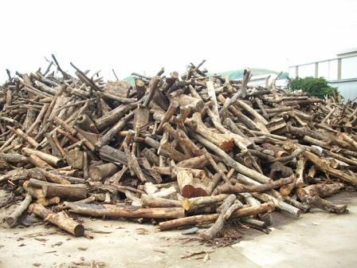 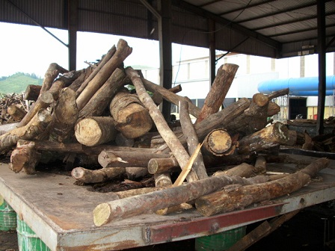

*Figure 8. Source of fuelwood consumed by industrial plants*

It is obvious that these wood are not Bamboo or Acacia, which are major trees of plantation forest in Thanh Hoa and Nghe An.

The reason that only natural forest fuelwood are used as fuelwood at the industrial plant is that the price of planted wood (Acacia) to sell as paper material is higher than natural wood. The price of Acacia at collection site at district (without transportation cost) is 750,000 – 850,000 VND per fresh ton after peeling the bark (right after cutting down, most of moisture is still contained), while the price of natural wood at collection site at district is from 500,000 to 550,000 VND per ton for partly dry wood (2-3 weeks after cutting down).

The natural forest fuelwood price is lower than the price for material wood because these natural wood are either in curved shape or of the species which are not preferred for furniture manufacturing. In other words, these natural wood cannot be sold as material wood to produce furniture. Therefore the price of fuelwood is lower than the price of Acacia.

For the case of the middleman in Lang Chanh district of Thanh Hoa, the man admits that 100% of his wood are exploited illegally. He has to arrange transportation without verification or permission papers.

However, for the case of the middleman in Nam Son commune, Quy Hop district of Nghe An, the fuelwood are exploited from the natural forest which are legally being converted into plantation forest. In this case the exploitation is legal. The middle man can get the verification document from commune officer to transport locally. However, when being asked if he can transport the wood to other provinces, he says that it is not possible because he cannot get the verification document from district ranger.

Since Quy Hop district is not in the list of the districts that VFD office arranges working session with local government officers, the investigator cannot meet with officers of Nam Son commune and Quy Hop district to verify the information about forest conversion and whether such exploitation of forest wood are legal or not. However, it is remarked that there is a grey area in legality of fuelwood and other natural wood being exploited in Nam Son commune, Quy Hop district, Nghe An province.

The below picture shows the plantation forest of Acacia was converted from natural forest. On the area that Acacia is planted, all natural trees were logged. In the next area, natural forest is still exist.

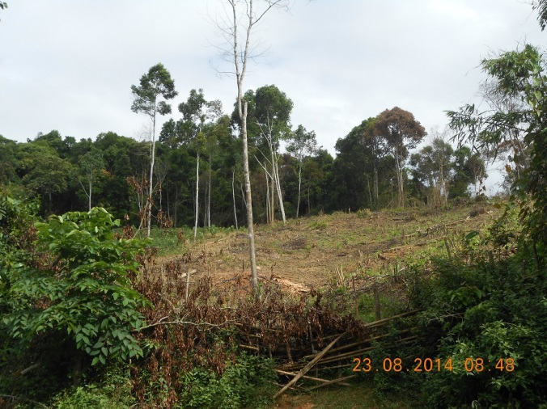

*Figure 9. Cleaning of natural forest for conversion to Acacia plantation forest*

#### Size of fuelwood consumed by local industrial plants

The size of the fuelwood of commercial demand is as below:

* For the middleman in Nam Son commune, Quy Hop district, Nghe An province: 60-70% of size 25cm and above, and the rest 30-40% is of size 15-25cm.
* For the middleman in Lang Chanh district, Thanh Hoa province: 20-30% of size 10-15cm, 50-60% of size 15-25cm, and 10% of size 25 cm and above.

For industrial consumption of fuelwood, the size of less than 10cm is not suitable for operation. The preferred size is from 15cm and above. The pictures below show the fuelwood at the plants.

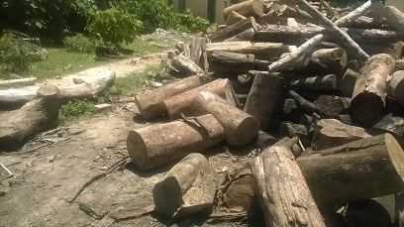 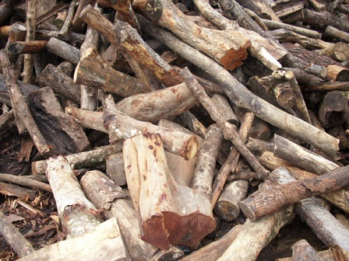

*Figure 10. Size of fuelwood consumed by industrial plants*

Based on the two cases investigated, it is estimated that fuelwood consumed by industrial plants include 15% of size 10-15cm, 50% of size 15-25cm, 35% of size 25cm and above.

#### Price of fuelwood that impacts the industrial plants’ choice for fuel

Investigation of middlemen and industrial plants show that fuelwood delivered at the plants are sold at the price of 600,000 to 650,000 VND per ton. The average moisture of the fuelwood is estimated at 35% as it is partly dried since logged.

The below table show the total calorific value of wood at oven dry condition.

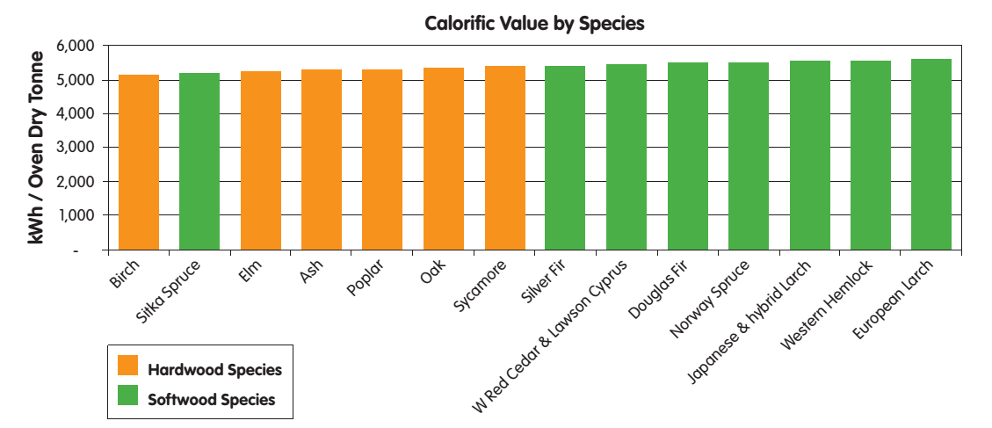

*Source: Wood as Fuel, Biomas Energy Center, 2010*

Based on above information, it is assumed that at oven dry condition, the fuelwood sold to local industrial plants has calorific value of 5,000 kWh per ton.

1 kWh = 860 kcal. Therefore it is assumed that a ton of fuelwood at oven dry condition has 4,300,000 kcal of total calorific value. It means the total calorific value of fuelwood at oven dry condition is 4,300 kcal/kg.

The fuelwood is sold at local industrial plants at the price of 650,000 VND per ton of moisture of 35%. It means the actual price of fuelwood per calorific value is 0.23 VND/ kcal.

Dust coal of total calorific value of 5,600 kcal/kg (TCVN 200:1995) at the actual moisture of 8% are sold in Thanh Hoa and Nghe An for the price of 1,950 VND per kg. It means the actual price of dust coal per calorific value is 0.38 VND/ kcal.

Coal of total calorific value of 7,500 kcal/kg (TCVN 200:1995) at the actual moisture of 8% are sold in Thanh Hoa and Nghe An for the price of 3,800 VND per kg. It means the actual price of dust coal per calorific value is 0.55 VND/ kcal.

It is obvious that the price per calorific value of fuelwood in Thanh Hoa and Nghe An is much cheaper than that of coal and dust coal. At the selling price of 600,000 – 650,000 VND per ton of fuelwood at 2014, industrial plants that locate at the distance of 50km from forest wood source certainly tends to switch to fuelwood rather than using coal and dust coal.

This has happened at a tea plant survey in Thanh Chuong district, with total installed capacity of 25 tons of fresh tea per day. Three years ago they used dust coal fired furnace to dry the tea. But since 2011 they switched to wood firing because it helped saving up to 30-35% of the fuel cost. The wood they bought are from Laos and Ha Tinh province because the distance of transport from Laos and Ha Tinh are closer than from other area of Nghe An (within 50km).

On the contrary, a paper mill in Hung Nguyen district in the delta area of Nghe An province choose to use coal for their boilers instead of fuelwood. The director of the plant says that he tried to use fuelwood before but it is not competitive in terms of costs.

## Fuelwood Value Chain Assessment

***Value chain of fuelwood in residential sector***

Amongst 220 household survey, only one household Hung Son commune, Anh Son district of Nghe An that sell fuelwood to a tea plant located in the same commune. The fuelwood that they sell are from the top and branches of Acacia plantation forest which is left after harvesting the Acacia trunk for paper material. Every year this household sells a total of 6 – 7 million VND of this biomass energy to the tea plant.

Other than this case, no other household surveyed sells fuelwood. Therefore it could be considered that there is no value chain of fuelwood in residential sector in Thanh Hoa and Nghe An.

It should be noted that 30 years ago fuelwood were prevailing sold at the markets in the region to supply to fuel demand of households from forest to delta. The disappearance of this fuelwood market for households also indicates that the situation of fuelwood consumption is changing significantly.

***Value chain of fuelwood in commercial and industrial sector***

The value chain of fuelwood is a chain of activities as below:

*Table 22. Fuelwood value chain in Thanh Hoa and Nghe An*

Consumption

Transportation

Prepare

Documentation

Logging Wood

Collecting, loading wood to Truck

|  |  |  |  |  |  |
| --- | --- | --- | --- | --- | --- |
| **Actor** | Farmer | Wood Collector | Middleman | Transporter | Industrial plants |
| **Activity** | Farmers logging of wood illegally or with legality unclear.  All logged wood are from natural forest or forest conversion.  He sells wood to the Wood Collector for 140,000 VND per ton. | The collector collect cut wood from several farmers and load wood onto his farm-vehicle.  He transport the wood collected to the truck parked by the village road.  He provides the labor to upload the wood to the truck hired by the Middleman.  He sells wood to the Middleman for 290,000 VND per ton. | The Middleman purchase fuelwood from several Wood Collectors to upload to one truck.  He is responsible for preparing transport documents for the wood and get verified by the commune officer.  He hires a transporter to transport wood to the industrial plant.  He sells wood for 650,000 VND per ton.  He has to pay the transporter for 180,000 VND per ton.  Hence he makes 180,000 VND per ton for the paper works. | The Transporter is hired by the Middleman to transport wood to the industrial plant.  The Middleman pay the transporter for 180,000 VND per ton for 50km of transportation.  The Transporter makes 180,000 VND per ton of wood. | The plant consumes wood at the price of 650,000 VND/ ton. |
| **Price of fuelwood at this stage** | 140,000 VND/ ton | 290,000 VND/ ton | 470,000 VND/ ton | 650,000 VND/ ton |  |
| **Location** | Natural forest near commune road | Collection site (commune road) | Commune office | Truck road, distance 50km | Industrial plant |
| **Income** | 140,000VND/ ton | 150,000 VND/ ton | 180,000 VND/ ton | 180,000 VND/ ton |  |

If the natural forest is 2km from truck road, then the wage for the wood logger is only half, of 70,000 VND per ton of wood. The wage for carry wood for 2km from the forest to truck road is 70,000 VND.

The price of fuelwood tends to remain stable in the last three years. According to VFD provincial officer of Nghe An province, the price of fuelwood tends to reduce because of the increasing supply of wood from Laos in recent years which has higher quality and lower price.

The value chain of fuelwood in Thanh Hoa and Nghe An is rather a simple one. In fact these activities are either illegal or with legality unidentified. Therefore it is not an ‘official value chain’, and the chain cannot be expanded farther than the distance of 50km. In other words, fuelwood exploited in Thanh Hoa and Nghe An are only to supply to local industrial demand.

All fuelwood for commercial demand are from natural forest. There is no afforestation activity for fuelwood. Therefore there is no value created from fuelwood afforestation. There is neither processing of fuelwood in the value chain.

There are no further chain outside of local industrial demand, no further commercial activities of transporting wood outside of the provinces.

***Value chain of charcoal***

Charcoal is not popularly used in the area of research. In fact, among 221 households surveyed and six plants using fuel visited, none of those use charcoal as a source of fuel. Therefore specific value chain of charcoal has not been investigated during the field.

Charcoal is produced in the region to supply to domestic demand and for export. For domestic demand, charcoal is mainly used for grilling food at home, restaurants, and for some other specific uses at small quantity. For export, statistics data on charcoal producers is not available.

Description of value chain of charcoal as part of the fuelwood value chain is as below:

Consumption at Local Plants

Transportation

Logging Wood

Domestic Retail

Domestic Wholesale

Charcoal Production

Foreign Import

Charcoal Export

|  |  |  |  |  |  |
| --- | --- | --- | --- | --- | --- |
| **Actor** |  | Transporter | Charcoal producer | Domestic Wholesale buyer  Charcoal exporter | Domestic Retailer  Foreign Importer |
| **Activity** |  | Transporting fuelwood to charcoal kiln | Operate charcoal kiln | Wholesaling  Exporting | Retailing  Foreign Importing |
| **Price of fuelwood at this stage** |  | 650,000 VND/ ton of fuelwood | 6-7 million VND/ton of charcoal | 8-10 million VND/ ton of charcoal | 12,000,000 VND/ ton of charcoal  (or 12,000 VND/ kg at the local market) |
| **Location** |  | Roads |  |  |  |
| **Income** |  | 180,000 VND/ ton | 1,800,000 VND/ ton | 2,000,000 VND/ ton | 4,000,000 VND/ ton |

According to several charcoal production studies, the amount of fuelwood consumption to produce 1 ton of charcoal can vary from 5 to 8 tons, depending on moisture content, species, and the efficiency of the kiln. It is assumed that at an average rate, it consumes 6.5 tons of fuelwood to produce 1 ton of charcoal. Therefore the income of the charcoal producer is estimated at 1,800,000 VND per ton of charcoal. The income of charcoal domestic wholesaler and exporter is estimated at 2,000,000 VND/ ton.

## Key factors driving deforestation and forest degradation

***Identifying the factors in household sector***

In summary, estimation of fuelwood demand of households is **1,641,182** ton per year including:

Estimation of fuelwood consumption for household in Thanh Hoa and Nghe An: 1,641,182 ton per year including 1,452,740 ton per year for household cooking, and 188,442 ton per year for pig raising. The fuelwood is supplied from following sources:

* 1,001,121 ton from natural forest
* 377,472 ton from plantation forest
* 262,589 tons from home garden.

The fuelwood demand for households by wood size are:

* 4% for size >15cm
* 26% for size 5-15cm
* 70% for size <5cm.

The total sustainable supply of fuelwood of dead trees, small trees and branches is calculated at **1,905,038** ton per year for the two provinces including:

* 1,157,136 ton per year from natural broad leaf forest
* 146,812 ton per year from mixed woody bamboo
* 31,897 ton per year from rock mountain forest
* 203,569 ton per year from bamboo forest
* 365,623 ton per year from Acacia plantation forest

This sustainable supply can in theory fulfill the major fuelwood demand for household of which 96% of somewhat 1 million from natural forest is fuelwood of size less than 5cm.

Given the population growth rate of Thanh Hoa for the year of 2013 is 1.16% and that of Nghe An is 0.68%, this growth rate does not create significant pressures on the supply, while the trend for fuel switch from wood to electricity and LPG is happening continuously.

However, there is one remarkable case in Tuong Duong district of Nghe An where natural forest is rapidly lost because of shifting cultivation. According to the district officer, the upland farm is only recorded on the document, but there is no parcel map and no official land certificate for this type of land use. Each year every household will clear 1-2 ha of regrowth or poor forest to grow corn and rice. This process is repeated every year on the large scale is the largest thread in deforestation. Because the shifting cultivation farm is a land use category recognized by local government the people have the right to use this type of land for agriculture cultivation. Since there is no clear boundary and no parcel map, it is very difficult to apply punishment to households that encroaching into forest because the location and boundary of his land cannot be identified in the first place. This annual activity of shifting cultivation include the activity of burning forest. After the burning, there are plenty of good big size natural wood for the household to use as fuelwood. According to these household, the natural wood collected from burning forest give them plenty of fuelwood for their cooking. It is even exceed their demand.

The below picture was taken with Tuong Duong district officer, that show the lost of natural forest caused by shifting cultivation.

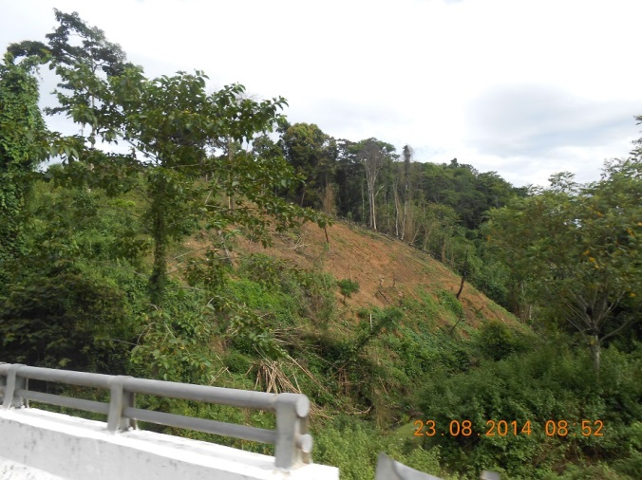

*Figure 11. Deforestation caused by shifting cultivation*

***Identifying the main causes in industrial sector***

Quantitative estimation for local industries’ fuelwood demand is not available for further analysis. However, qualitative assessment of commercial fuelwood demand and industrial fuelwood consumption shows that the 100% fuelwood consumed by industrial sector is exploited from natural forest, in which 85% are of the size more than 15cm. As having analyzed above for the two locations investigated, local industrial plants consume more than two third of fuelwood of size 15cm and above exploited from natural forest. Therefore it is suspected that fuelwood consumption of this sector is one of the major factors driving forest degradation.

In addition, larger size of wood from natural forest are also exploited and supplied as material wood at MDF and furniture manufacturers. Therefore it requires further investigation of local industrial demand for wood of both fuelwood and material wood to identify key factors that driving forest degradation.

# Recommendations

## Review of land conversion in some specific area

The provincial plan to convert natural forest to plantation forest to develop Acacia trees for paper materials needs to be reviewed carefully. While selling Acacia may lead to a direct increase in income of farmers and households as the price of Acacia is higher than the price of natural wood to be sold as fuelwood, a vast plan for this conversion may cause a serious and large scale of forest degradation and consequently decrease of protection function for soil and water.

## Forest land administration improvement in some specific area

The main cause of deforestation is shifting cultivation on the upland area. In Tuong Duong district the upland farm is only recorded on the document but there is no parcel map and no official land certificate for this type of land use. Each year each household in the upland will clear 1-2 ha of regrowth or poor forest to cultivate corn and rice. This process, repeated every year on the large scale, is the largest thread in forest degradation and deforestation. Because the shifting cultivation farm is a land use category recognized by local government the people have the right to use this type of land for agriculture cultivation. Since there is no clear boundary and no parcel map, it is very difficult to give punishment to households that encroaching into forest because the location and boundary of his land cannot be identified in the first place.

It is recommended that Thanh Hoa and Nghe An to implement mapping of shifting cultivation land in the up land area.

## Improved stoves

A program of improved stoves could be introduced to selected households that raise pigs or have additional jobs at bigger scale. Amongst the 41 households surveyed that have supplement jobs, 29 of those consume from 500kg to 1200kg of fuelwood per month. To these households, saving wood is relating to saving costs. Therefore improved stoves program may have more opportunity for success. This could lead to less demand for fuelwood.

## Agriculture residues utilization as an alternative source to fuelwood

There is a potential of using agriculture residues to fulfill a significant amount of biomass energy demand. A program to encourage people switching from fuelwood to agriculture biomass could be considered as a solution to reduce fuelwood consumption.

## Creation of fuelwood source

As the demand for fuelwood will not decrease significantly in coming years, a program of activities for planting fuelwood should be considered to create fuelwood for the future. Selected tree species that grow fast and provide high quality wood could be considered for plantation including Melia Azedarach, Eucalyptus Camaldulensis. Commune’s public land and unused land might be used for this purpose.

## Further investigation of local industrial fuelwood demand

Since there is not sufficient data to estimate local fuelwood demand, it is recommended that further investigation should be conducted for this sector.

In terms of qualitative analysis, 100% fuelwood consumed for this sector is from natural forest in which 15% of size 10-15cm, 50% of size 15-25cm, 35% of size >25cm. Therefore it is contributing to exploitation of larger size of trees from natural forest.

However it should be noted that for MDF plants, 90% of wood is used as material wood, and 10% is used as fuelwood. Besides that, most valuable wood from natural forest are exploited for furniture production. There is a competence of the same supply source for natural wood for different use purposes of fuelwood and material wood.

Therefore in order to identify the key drivers driving forest degradation, it requires a further and thorough investigation on local industries.

# Appendix

**Appendix 1. List of plants visited**

|  |  |  |
| --- | --- | --- |
| **Name** | **Industry** | **Location** |
| Lang Chanh Forest product processing Cooperationn – Quang Hien paper mill | Paper mill | Quang Hien commune, Lang Chanh district, Thanh Hoa province |
| Hung Son Tea processing plant | Tea processing | Village 5, Hung Son commune, Anh Son district, Nghe An province |
| Song Lam paper mill | Paper mill | Hung Phu commune, Hung Nguyen district, Nghe An province |
| Muc Son paper mill | Paper mill | Lam Son town, Thanh Hoa province |
| Ngoc Lam Tea processing plant | Tea processing | Thanh Thuy commune, Thanh Chuong district, Nghe An |
| Nam Thanh Industrial Wood processing plant | MDF plant | Bai Chanh Industrial Zone, Xuan Binh commune, Nhu Xuan district, Thanh Hoa province |
| Forest product import export plant | Wood chipper | Bai Chanh Industrial Zone, Xuan Binh commune, Nhu Xuan district, Thanh Hoa province |

**Appendix 2. List of middleman interviewed**

|  |  |  |
| --- | --- | --- |
| **Name** | **Type of wood/ product** | **Location** |
| Mr. Giang | Wood from natural forest | Nam Son commune, Quy Hop district, Nghe An province |
| Mr. Duc | Wood from natural forest | Lang Chanh town, Lang Chanh district, Thanh Hoa province |
| Mr. Bui Van Tham | Acacia | Ngoc Lac district, Thanh Hoa province |
| Mr. Bao Sinh | Bamboo | Lang Chanh town, Lang Chanh district, Thanh Hoa province |
| Mr. Hoang Van Than | Bamboo | Lang Chanh town, Lang Chanh district, Thanh Hoa province |

**Appendix 3. Sustainable supply of wood by districts (Unit: ton per year)**

|  |  |  |  |  |
| --- | --- | --- | --- | --- |
| **By district** | **Wood supply**  **(ton/ year)** |  | **By district** | **Wood supply**  **(ton/ year)** |
| **Nghe An** | **1,193,421** |  | **Thanh Hoa** | **711,617** |
| Anh Sơn | 42,676 |  | Bá Thước | 52,851 |
| Con Cuông | 203,715 |  | Bim Son | 1,537 |
| Cửa Lò | 449 |  | Cẩm Thủy | 17,827 |
| Diễn Châu | 9,103 |  | Đông Sơn | 298 |
| Đô Lương | 14,365 |  | Hà Trung | 6,786 |
| Hưng Nguyên | 2,101 |  | Hậu Lộc | 1,818 |
| Kỳ Sơn | 106,720 |  | Hoằng Hóa | 2,103 |
| Nam Đàn | 10,981 |  | Lang Chánh | 66,591 |
| Nghi Lộc | 13,481 |  | Mường Lát | 63,828 |
| Nghĩa Đàn | 23,359 |  | Nga Sơn | 432 |
| Quế Phong | 204,918 |  | Ngọc Lạc | 28,086 |
| Quỳ Châu | 109,230 |  | Như Thanh | 34,725 |
| Quỳ Hợp | 52,252 |  | Như Xuân | 60,116 |
| Quỳnh Lưu | 19,867 |  | Nông Cống | 3,976 |
| Tân Kỳ | 30,360 |  | Quan Hóa | 106,204 |
| Thái Ḥa | 3,582 |  | Quan Sơn | 107,492 |
| Thanh Chương | 95,387 |  | Quảng Xương | 446 |
| Tương Dương | 231,432 |  | Sầm Sơn | 434 |
| Vinh | 87 |  | Thạch Thành | 25,595 |
| Yên Thành | 19,356 |  | Thanh Hóa City | 392 |
|  |  |  | Thiệu Hóa | 228 |
|  |  |  | Thọ Xuân | 2,956 |
|  |  |  | Thường Xuân | 96,600 |
|  |  |  | Tĩnh Gia | 20,719 |
|  |  |  | Triệu Sơn | 5,036 |
|  |  |  | Vĩnh Lộc | 3,159 |
|  |  |  | Yên Định | 1,385 |

1. R. Johnson and D. Wichern (1992). *Applied Multivariate Statistical Methods*, Third Edition. Prentice Hall.
2. Preliminary account of litter production in a New Zealand lowland podocarp-ratabroadleaf forest, New Zealand Journal of Botany, 13:2, 173-187
3. Scheer, Maurício Bergamini, et al. "Patterns of litter production in a secondary alluvial Atlantic Rain Forest in southern Brazil." Brazilian Journal of Botany 32.4 (2009): 805-817.
4. Litter production and leaf-litter decomposition in natural and monoculture plantation forests of Castanopsis kawakamii in subtropical China
5. D.T. Le. Et al “Litter production of the secondary forest in Me Linh, Vinh Phuc provice. Vietnam Journal of Biology (2009)
6. Nordeco (2010). Technical report: Technical Assistance in the Development of the National REDD Programme of Vietnam. Component of Collecting Information and Analyzing Trends of Forest Resources and Forest Carbon Stock for Establishment of the Interim Baseline Reference Scenarios (Danish Forestry Extension / Nordeco, 2010)